**Experiment No. 5  
Aim:** Installation and configuration of virtual machine with guest OS.  
**Theory:**The guest operating system, typically **Windows or Linux**, is installed into a virtual machine,  
much the same way that it is installed on a traditional physical machine. Each instance of a guest operating system runs in a separate virtual machine.  
The virtual machine component of the VMware virtual infrastructure represents virtualized hardware on which a guest operating system runs. The guest operating system, typically Windows or Linux, is installed into a virtual machine, much the same way that it is installed on a traditional physical machine. Each instance of a guest operating system runs in a separate virtual machine.  
VMware offers several tools for managing and monitoring virtual infrastructure: VirtualCenter, the Management User Interface (MUI),vmkusage, and the esxtop service console utility. VMware virtual  
infrastructure management tools are designed to manage and monitor virtual machines -- not guest operating systems.  
**Points to be included:**1. What is Virtualization?  
**Virtualization** relies on software to simulate hardware functionality and create a virtual  
computer system.  
2. Advantages and disadvantages of Virtualization(Each three)

Pros of Virtualization  
**Uses Hardware Efficiently**Most businesses spend a lot of capital setting up their systems and servers but eventually use only a fraction of it effectively.  
Instead, if they opt for virtualization, they can create multiple instances on the same hardware and extract the maximum value out of it. This way, they can save hardware costs and attain a high-efficiency level.

**Available at all Times**One significant advantage of virtualization is the advanced features that it provides;  
allowing virtual instances to be available at all times.  
The biggest advantage here is the capability to move the virtual instance from one server location to another. It can be done without having to close and restart the processes that are already running.  
It also ensures your data is not lost during the migration process. Hence, it won’t matter if there are unplanned outages, your instance will always be up and running at all times.  
Virtualization service providers are thus providing 99.999% uptime today owing to the same reason.  
**Quick and Easy Setup**Setting up physical systems and servers is a time-consuming affair. You need to raise a purchase order and wait for it to be processed.  
Once done, then await the products to be shipped and set up, which can take hours.  
After getting all the connections right, you still have to install the required OS and software which consumes more hours.  
Overall, it is a long wait worth days or even weeks for the entire setting-up process.  
On the flipside, with virtualization, you can simply get started within minutes have a productive setup.  
**Cons of Virtualization**  
**High Initial Investment**As helpful virtualization is, it does have some flaws, and the high initial investment is one of the major one.  
Virtualization indeed helps the business reduce operational costs. But the initial setup cost of servers and storage is higher than a regular setup.  
Hence, companies need years before they break even and then realize savings and higher profitability with virtualization.  
It is a bad bet for companies opting for a large set up at the beginning.  
They could instead opt for a regular desktop setup and then gradually make a move to desktop virtualization.  
**Data Can be at Risk**Working on virtual instances on shared hardware resources entails your data is hosted on a third-party resource.  
It can leave your data vulnerable to attacks or unauthorized access. This is a challenge if your service provider does not have proper security solutions to safeguard your virtual instance and data.  
It is true, specifically in the case of storage virtualization.  
**Quick Scalability is a Challenge**Scaling on virtualization is a breeze, but not so much if it has to be done in a short period of time.  
In case of physical setup, one can quickly set up new hardware and scale, even if it entails some initial setting up complications.  
With virtualization, having to ensure all the requisite software, security, enough storage, and resource availability can be a tedious task.  
It consumes more time than one might expect since a third-party provider is involved.  
Moreover, the additional cost involved in increased resource use is another challenge to manage.  
3. What is Hypervisor? What is the difference between process, host and native  
VMMs?  
A hypervisor, also known as a virtual machine monitor or VMM, is **software that  
creates and runs virtual machines (VMs)**. A hypervisor allows one host computer  
to support multiple guest VMs by virtually sharing its resources, such as memory  
and processing.  
• **Process virtual machine** in cloud computing also called the application virtual  
machine. IT runs as a normal application inside a host operating system and it supports a single process. The process virtual machines run the same as any normal application in any operating system like it is created when the process is started and it quits when the process is destroyed.  
The main purpose is to provide a platform-independent programming environment that abstract awaits details of the hardware and the operating system. process virtual machine allows a program to execute in the same way as the normal program executes on any platform or operating system.

Example of process virtual machine is VMWare. This software is supported on Linux, Windows, and Mac.

**Process Virtual machine:**

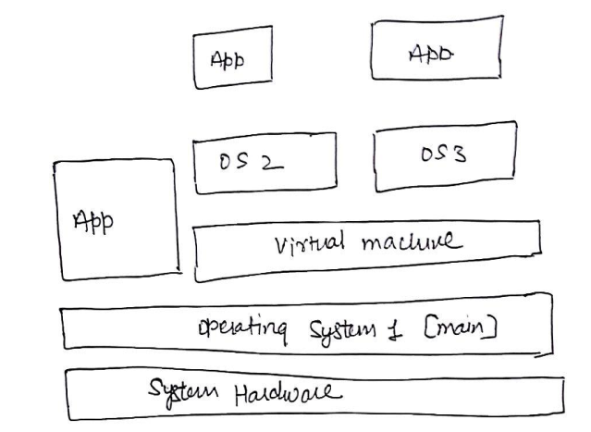

**Host virtual machine** is a server component of a virtual machine, in this host  
virtual machine provides all the computing resources which the system  
requirements and it underlying upon the hardware and its support system virtual  
machine. By this, we can have multiple instances and all the resources which are  
required for that instance are being provided by the host virtual machine.  
• **Native Virtualization**Native virtualization depends on a virtualizable processor architecture, such as is available with the  
x86 Intel-VT and AMD-V series. These processors implement new execution modes, instructions,  
and data constructs in hardware that are designed to reduce the complexity of the VMM.  
With native virtualization, the VMM is no longer required to maintain virtual machine resource  
characteristics and state in software; these functions now belong to the processor hardware and  
logic. Just as in the case of full virtualization, operating systems can run unmodified inside the  
virtual machines. Windows Server Virtualization will use this method to run legacy operating  
systems.  
This type of implementation has many potential benefits ranging from the simplification of the  
VMM architecture to significant performance improvements due to reduction of software-based  
overhead. By lowering the virtualization overhead, a greater partition density can be achieved on  
any single system.  
4.Steps(screenshot) to install Virtual Box/VMware and ubuntu o.s. (with  
screenshots).  
**1. Open the VirtualBox website.** Go to https://www.virtualbox.org/ in your computer's  
Internet browser. This is the website from which you'll download the VirtualBox setup  
file.